A12 - User Manual

Year: 2023 Semester: Fall Team: 8 Project: Smart Seat System

Creation Date: November 18, 20233 Last Modified: November 18, 2023

Author: Giang Nguyen Email: nguye683@purdue.edu

Assignment Evaluation: See the Rubric in the Brightspace Assignment

1. Product Description

Introducing Smart Seat System, a cutting-edge solution designed to revolutionize the way educational institutions, healthcare facilities, and security-sensitive environments approach seating arrangements and surveillance. Tailored to meet the unique needs of diverse user demographics, our product seamlessly integrates with your existing infrastructure to enhance safety, efficiency, and overall user experience.

For Educational Institutions:

Are you looking to optimize classroom attendance? The Smart Seat System offers precise attendance tracking, allowing educators to identify trends, track individual student attendance records, and streamline the overall learning process. This not only ensures compliance with fire codes but also facilitates targeted interventions for student success.

For Healthcare Monitoring:

Catering to users of all age ranges, the Smart Seat System transforms healthcare settings into personalized, patient-centric spaces. It provides healthcare providers with real-time data on patient seating preferences, enabling staff to create customized seating arrangements that enhance patient comfort and satisfaction. This adaptability ensures that healthcare spaces are not just functional but also empathetic to the individual needs of each patient.

For Security and Surveillance:

Security is paramount, and the Smart Seat System takes it to the next level. In security-sensitive environments such as airports, the system provides insights into seating patterns, helping security personnel identify unusual behavior or potential security threats. It optimizes security layouts for better visibility, ensuring that the right security measures are in place without compromising user comfort.

Investing in the Smart Seat System means experiencing a tailored solution that goes beyond mere seating tracking. It's about leveraging data to make informed decisions, enhance user experiences, and contribute to the overall efficiency and safety of educational institutions, healthcare facilities, and security-sensitive environments.

1. Product Illustrations

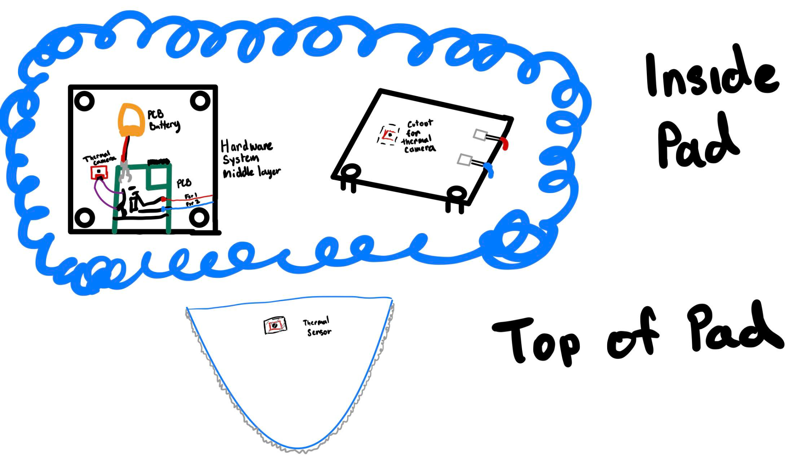

1. / 4.0 Setup and Usage Instructions

The Smart Seating System comprises of two major components: the seating pad and the internal hardware (hardware packaging, PCB, thermal camera, force resistive sensors, and Li-Po battery). An external PC is required to run a web server with the associated seating system. The Smart Seating System will come pre-packaged but the setup and usage are describe below for any user needs. Follow these comprehensive steps to set up, use, and maintain your Smart Seating System seamlessly:

1. Initial Setup:

* Connect the dedicated Power Supply to ensure the entire system, including the Chair Microcontroller and sensors, is powered.
* Setup the server on the dedicated server PC
* Power on the System.

2. Connect to the Web Server:

* Verify the PC is connected to the Internet, either through Wi-Fi or Ethernet.
* The system will automatically connect to the designated Web Server.

3. Accessing Seating Information:

* Open the Smart System web address or check designated display screens within the public space.

4. Real-time Seating Information:

* View symbol indicators on the app or display screen:

- Blue Chair: Seat is available

- Red: Seat is not available

5. Choosing a Seat:

* Based on the provided information, select a seating area that suits your preferences.

6. Hands-Off Reservation:

* The Smart Seat System eliminates the need for formal check-ins or reservations. Simply use the provided information to make informed decisions on available seating.

7. Maintenance Instructions:

* Updating the Mobile App:
* Regularly update the Smart System mobile app for the latest features and improvements.
* Firmware Updates:
* Follow in-app prompts for any firmware updates to ensure the system is running the latest version.
* Battery Management:
* Monitor the battery level through the app and replace batteries as needed.
* For wired systems, ensure a stable power supply for uninterrupted service.

8. Trou leshooting:

* In case of discrepancies or issues with seating information, contact the venue's staff or customer support for assistance.

9. System Administrator Tasks:

* System administrators (IT personnel) should perform setup tasks, including networking, and changing batteries.
* Follow the setup process outlined in the system documentation for efficient configuration.

1. Troubleshooting Instructions

**Troubleshooting**

| Issue | Probable Cause | Solution |
| --- | --- | --- |
| No Seats Displayed on the App | - Power supply issues | - Check power connections for the Hub and Chair Microcontrollers. Ensure the system is powered on. |
|  | - Connectivity problems | - Verify Wi-Fi/Ethernet connection. Check for any network issues. |
|  | - Web Server communication failure | - Confirm the Web Server's status. Check if there are any server-side issues. |
| Incorrect Seat Occupancy | - Sensor calibration errors | - Recalibrate sensors on the Chair Microcontroller. Follow the calibration process outlined in the system documentation. |
|  | - Communication disruptions between sensors | - Inspect sensor connections. Ensure there are no loose wires or damaged components. |
| App Not Updating | - App version outdated | - Update the Smart Seating System mobile app to the latest version. |
|  | - Web Server synchronization issues | - Check the Web Server's status. Ensure it is receiving and processing data from the Control Units. |
| Bluetooth/Wi-Fi Connection | - Signal interference | - Move closer to the PC (Server). Remove any potential sources of interference (e.g., electronic devices, large metal objects). |
|  | - Device pairing issues | - Reconnect the device to the Hub Microcontroller. Follow the pairing instructions in the system documentation. |
| System Freezing or Crashing | - Insufficient system resources | - Check for any memory-related issues on the Control Unit. Restart the system to free up resources. |
|  | - Firmware bugs or glitches | - Update the firmware to the latest version. Follow the firmware update instructions in the system documentation. |

**Customer Support:**

For additional assistance, please contact our Customer Support:

Phone: 206-889-3845

Email: nguye683@purdue.edu

For the best support experience, provide detailed information about the issue, including error messages and steps leading to the problem. Our support team is ready to assist you!